For Thumbnails to get create automatically,

- Add automation – update below xml in to the MediaAutomations generic resource as shown in below figure.
<automations>
<automation>
<!--unique identifier -->
<id>imageautomationsforthumbnail</id>
<!--type of automation -->
<type>upload</type>
<!--display name -->
<name>Thumbnail Image</name>
<!-- type of media item this automation applies to -->
<targetType>DSX-MEDIA-IMAGE</targetType>
<!-- tooltip or hover text -->
<description>Automatically creates three sizes of images from the source.</description>
<actions>
<createformat width="160" height="120" fileappend="thumbnail" sizeformat="small" deviceformat="web" resizetype="crop"/>
</actions>
</automation>
</automations>

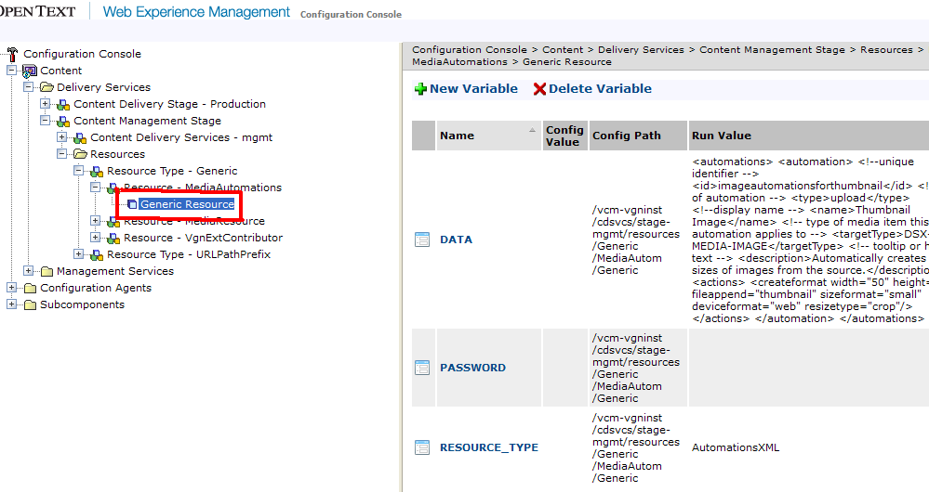

- Restart mgmt DA
- To test above automation working, Login into /content
- Use Upload button to create (not New content button)
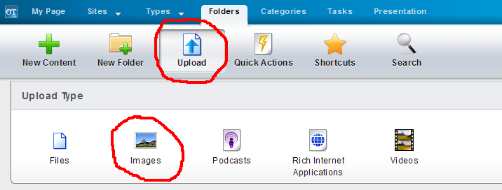

- Select the automation for Thumbnails to get created.
